IPS Exam 2023

1. L is a regular language, for example it is recognized by the following DFA:  
   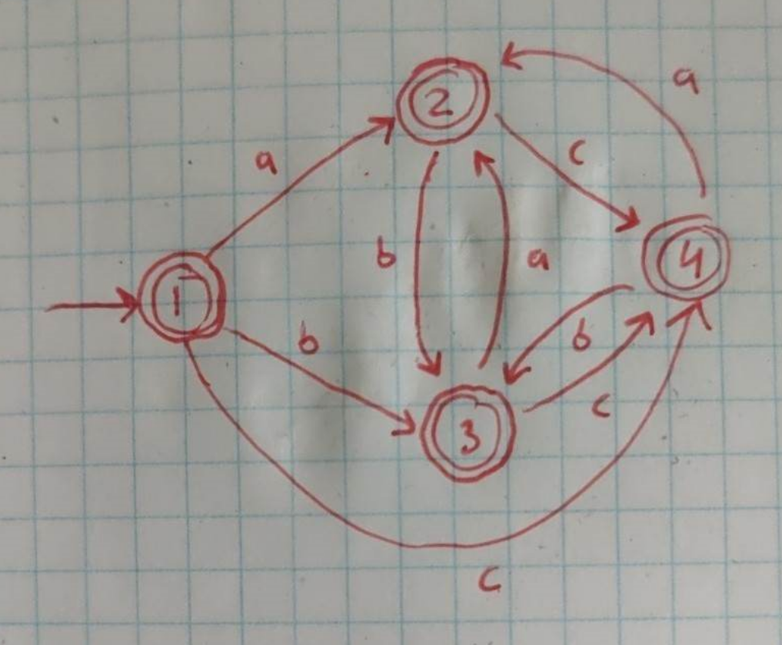
2. L’ is also a regular language. This can be shown by a somewhat larger DFA, with essentially three copies of the above one, one for each possible starting letter. Alternatively, we can note that $L’ = L / M$, where M is the language consisting of words that start and end with the same letter. This suffices, because regular languages are closed under set difference (or intersection and complementation), and M is evidently expressible with the following regular expression:

DFA:

Preprocessing: add new, rejecting state 7, replacing all originally undefined transitions with transitions to state 7.

$$G1=\left\{2, 3, 5\right\} ACCEPTING$$

$$G2=\left\{1, 4, 6, 7\right\} REJECTING$$

G1 a b c

-----------------------------------

2 G1 G2 G1 => G3

3 G1 G2 G1 => G3

5 G2 G2 G2 => G4

Inconsistent

$$G3=\left\{2, 3\right\}$$

$$G4=\left\{5\right\}$$

G2 a b c

-----------------------------------

1 G3 G3 G1 => G5

4 G2 G2 G2 => G6

6 G2 G2 G2 => G6

7 G2 G2 G2 => G6

Inconsistent

$$G5=\left\{1\right\}$$

$$G6=\left\{4, 6, 7\right\}$$

G6 a b c

-----------------------------------

4 G6 G6 G6

6 G6 G6 G6

7 G6 G2 G6

Remove this group as they are dead states.

G3 a b c

-----------------------------------

2 G4 G6 G3

3 G4 G6 G3

G4 a b c

-----------------------------------

5 G6 G6 G5

G5 a b c

-----------------------------------

1 G4 G3 G6

a b c

------------------------------------

G3 G4 - G3 ACCEPTING

G4 - - G5 ACCEPTING

G5 G4 G3 - REJECTING, START

1. No cannot be derived from G.
2. Yes $baca$ can be derived from G:

$S=>A=>AcA=>AcB=>Aca=>ABca=>Aaca=>Baca=>baca$

1. The string $acaa$ have different syntax trees:  
   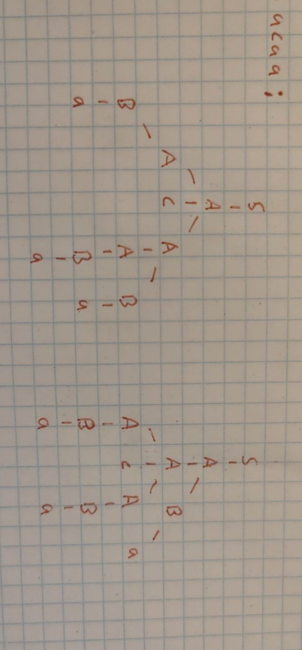
2. Yes, L(G) is a regular language because it can be described by regular expressions:

${\left(a | b\right)}^{+}{\left(c{\left(a | b\right)}^{+}\right)}^{*}$ or ${\left({\left(a | b\right)}^{+}c\right)}^{*}{\left(a | b\right)}^{+}$

1. S -> A

A -> DcA

A -> D

D -> DB

D -> B

B -> a

B -> b

1. Computing nullable(N) [abbreviated as null(N)] for all N:
$$null(S) = false [always, because of the \$]$$

$$null\left(A\right)=null\left(\left[ B \right]\right)$$

$$=null\left(\left[ \right) \& null\left(B\right) \& null\left( \right]\right) \\ =true \& false \& true=false$$

$$null\left(B\right)= null\left(2C\right) || null\left(eps\right) \\ =(null\left(2\right) \& null\left(C\right)) || null(eps) \\ =(true \& false) || true = true$$

$$null\left(C\right)= null\left(0B\right) || null\left(1B\right) \\ = \left(null\left(0\right) \& null\left(B\right)\right) || (null\left(1\right) \& null\left(B\right)$$

$$=\left(true \& false\right) || (true \& false)$$

$$=false || false = false$$

2. Computing first(N) for all N: $$first(S) = first(A \$) = first\left(A\right) [since !null(A)]$$

$$first(A) = first([ B ]) = \{[ \}$$

$$first(B) = first(2C) U first(eps) = \{2\} U \{ \} = \{2\}$$

$$first(C) = first(0B) U first(1B) = \{0\} U \{1\} = \{0, 1\}$$

Simplifying further:

$$first(S) = first(F) = \{[ \}$$

1. Computing follow(N) for all N: $$Production Contraints \\ S→A\$ \left\{\$\right\} ⊆ follow\left(A\right) \\ A→\left[B\right] \left\{]\right\} ⊆ follow\left(B\right) \\ B→2C follow\left(B\right)⊆ follow\left(C\right) \\ B→eps \\ C→0B follow\left(C\right)⊆follow(B)$$
$follow\left(A\right)=\left\{\$\right\}$ $$follow\left(B\right)) \left\{ \right]\} \\ follow\left(C\right)=\{ ]\}$$

$la\left(S→A\$\right)=first\left(A\right)=\left\{ \right\}$ $$la\left(A→\left[B\right]\right)=first\left(\left[ B \right]\right)=\{[ \} \\ la\left(B→2C\right)=first\left(2C\right)=\left\{2\right\} \\ la\left(B→eps\right)=first\left(eps\right) U follow\left(B\right)=\{ ]\} \\ la\left(C→0B\right)=first\left(0B\right)=\left\{0\right\} \\ la\left(C→1B\right)=first\left(1B\right)=\{1\}$$

2. ?
3. ?
4. LL(1) parsers perform leftmost derivations.

1. A picture containing text, handwriting, line, number

   Description automatically generated
2. The type variables: $alpha=int$, $beta=list(int)$
3. The unified type expression:

1. Answer: (B)   
   and (E)
2. Answer: (C)

|  |  |  |  |
| --- | --- | --- | --- |
| i | succ[i] | gen[i] | kill[i] |
| 1 | 2 | x,y | a |
| 2 | 3 | x | b |
| 3 | 4 |  |  |
| 4 | 5 | b,y | b |
| 5 | 6, 10 | a,b |  |
| 6 | 7 |  |  |
| 7 | 8 | b | y |
| 8 | 9 | y | b |
| 9 | 3 |  |  |
| 10 | 11 |  |  |
| 11 | - | b |  |

|  |  |  |  |  |  |  |
| --- | --- | --- | --- | --- | --- | --- |
| i | out[i]_0 | in[i]_0 | out[i]_1 | in[i]_1 | out[i]_2 | in[i]_2 |
| 1 |  |  | a,x,y | x,y | a,x,y | x,y |
| 2 |  |  | a,b,y | a,x,y | a,b,y | a,x,y |
| 3 |  |  | a,b,y | a,b,y | a,b,y | a,b,y |
| 4 |  |  | a,b | a,b,y | a,b | a,b,y |
| 5 |  |  | b | a,b | a,b | a,b |
| 6 |  |  | b | b | a,b | a,b |
| 7 |  |  | y | b | a,y | a,b |
| 8 |  |  |  | y | a,b.y | a,y |
| 9 |  |  |  |  | a,b,y | a.b.y |
| 10 |  |  | b | b | b | b |
| 11 |  |  |  | b |  | b |

|  |  |  |  |
| --- | --- | --- | --- |
| i | kill[i] | out[i] | interferes with |
| 1 | a | a,x,y | x,y |
| 2 | b | a,b,y | a,y |
| 3 |  | a,b,y |  |
| 4 | b | a,b | a |
| 5 |  | a,b |  |
| 6 |  | a,b |  |
| 7 | y | a,y | a |
| 8 | b | a,b.y | a,y |
| 9 |  | a,b,y |  |
| 10 |  | b |  |
| 11 |  |  |  |

|  |  |  |
| --- | --- | --- |
| Node | Neighbors | Color |
| a | - | 1 |
| b | a | 2 |
| x | a | 2 |
| y | a,b | 3 |

1. Three main actions are taken:

(1) Spill code is inserted in the program for each variable marked ’spill’, so it can be kept in memory M. After this rewrite of the program, (2) liveness analysis and (3) register allocations are performed again. A subsequent register allocation may generate new spilled variables, and the steps are repeated.